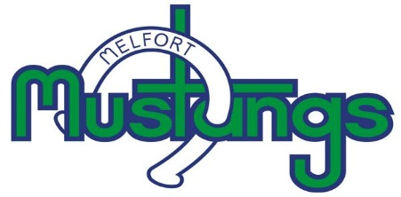
Melfort Mustangs Board Members
2020/21 Season

President: Chad Elliott
Vise President: Jordan Lee
Treasure: Connie Van Camp
Secretary: Connie Carter
Governor: Lionel Shmyr
Billet Coordinator: Jody Goodfellow
Director: Darin Placsko
Director: Jamie Placsko
Director: Larry Rempel
Director: Jeff Pederson
Director: Greg Claypool
Director: Andrew DeHaan

