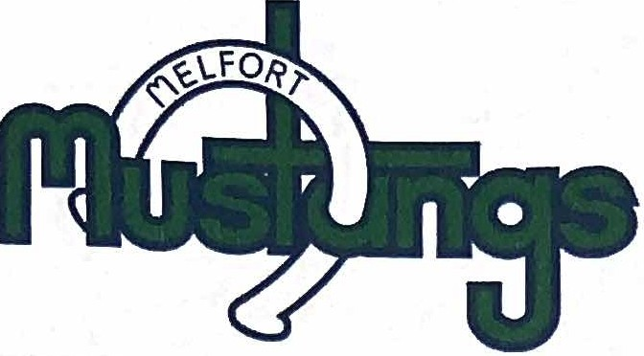
Me/fort Junior · Mustangs Saskatchewan Junior Hockey League
Phone: 306-752-2799
Fax: 306-752-3899
Box 3640 Me/fort, SK SOE 1AO

Our regular season record last season was 32 wins, 17 losses, 6 overtime losses and 3 shoot-out losses for 73 points. We finished 3rd in the regular season standings and in our last 10 games of the season, we were playing our best hockey of the year. We also performed very well in our 1st round vs Estevan as we were up 3 games to 1 coming home for game 5.

We want to thank our team for their tremendous effort in the community of Melfort and on the ice. We had a great year with our players being involved in the city of Melfort and we had lots of positive feedback from many businesses and community groups. We were very involved with minor hockey practices, elementary schools, Salvation Army and many more. Specifically we want to recognize our graduating 20 year old group. We want to thank every one of these men for their leadership and contribution to our organization.
The following is a summary of each player’s plans for next season:

Alex Rondeau -Alaska Fairbanks
Nolan Kadachuk - Marian University (Wisconsin) Tyson Meyers - continuing education at the U of S Zach Anderson - Briercrest
Kyle Bosch - continuing education at Red Deer College Austin Nault - St. Thomas University (Minnesota) Kenzie Arnold - continuing education
Tian Rask - University of British Columbia Shawn Parkinson - Grant McEwen (Edmonton)

We would also like to thank our hockey staff: Trevor Logan, Shawn Mason and Justin Rempel. We are happy to announce that all are

back for next season. Jaret Schneider has many responsibilities in our organization and we appreciate the work he does for the hockey operations.

We did make 2 player transactions this summer. We wish Christian Albertson all the best in his hockey career as he will be with the Nipawin Hawks this coming season. Thank you for your time and commitment as a Melfort Mustang. Also, we acquired 20 year old Leighton Burns-Marion from the Calgary Canucks in the Alberta Junior Hockey League. He will be a great addition to our forward group with his size, strength, skill and compete level.

We are very excited about our recruiting class. We have players signed from all over Canada and many will step in and make an immediate impact.

In closing, on behalf of the hockey operations staff we want to thank all people involved that contribute to the success of the Melfort Mustangs. The board of directors, billets, sponsors, volunteers and fans. We appreciate all of your contributions so that we can remain an elite program in the Saskatchewan Junior Hockey League.

Yours in hockey,

(c/ .
Trevor Blevins
GM/Head Coach
Melfort Mustangs Junior A Hockey Club

